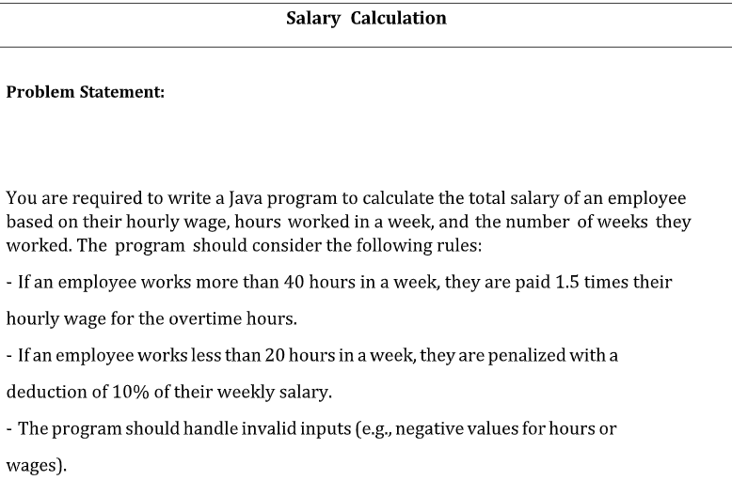

import java.util.Scanner;

public class SC {

public static void main(String[] args) {

Scanner sc = new Scanner(System.in);

double wage = sc.nextDouble();

if (wage < 0) {

System.out.println("Hourly wage cannot be negative.");

return;

}

int hPerWk = sc.nextInt();

if (hPerWk < 0) {

System.out.println("Hours per week cannot be negative.");

return;

}

int wks = sc.nextInt();

if (wks < 0) {

System.out.println("Weeks worked cannot be negative.");

return;

}

double wkSal;

if (hPerWk > 40) {

double regHrs = 40;

double ovtHrs = hPerWk - 40;

wkSal = (regHrs \* wage) + (ovtHrs \* wage \* 1.5);

} else {

wkSal = hPerWk \* wage;

}

if (hPerWk < 20) {

wkSal \*= 0.9;

}

double totSal = wkSal \* wks;

System.out.printf("Total salary is %.1f\n", totSal);

}

}

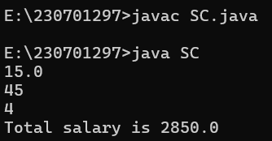

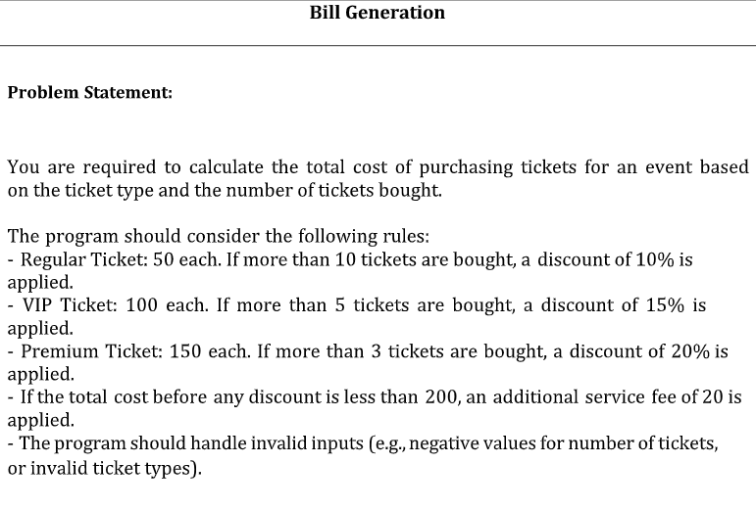

import java.util.Scanner;

public class BG {

public static void main(String[] args) {

Scanner sc = new Scanner(System.in);

System.out.print("Enter ticket type (Regular, VIP, Premium): ");

String type = sc.nextLine().trim();

System.out.print("Enter number of tickets: ");

int qty = sc.nextInt();

if (qty < 0) {

System.out.println("Number of tickets cannot be negative.");

return;

}

double pricePerTicket = 0.0;

double discount = 0.0;

switch (type) {

case "Regular":

pricePerTicket = 50.0;

if (qty > 10) discount = 0.10;

break;

case "VIP":

pricePerTicket = 100.0;

if (qty > 5) discount = 0.15;

break;

case "Premium":

pricePerTicket = 150.0;

if (qty > 3) discount = 0.20;

break;

default:

System.out.println("Invalid ticket type.");

return;

}

double totalCost = qty \* pricePerTicket;

totalCost -= totalCost \* discount;

if (totalCost < 200) totalCost += 20;

System.out.printf("%.1f\n", totalCost);

}

}

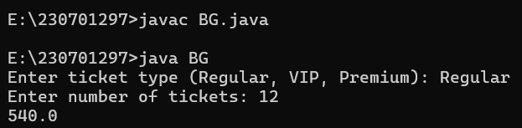

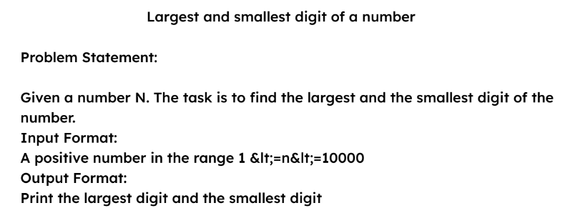

import java.util.Scanner;

public class LSN{

public static void main(String args[]){

Scanner sc = new Scanner(System.in);

int num = sc.nextInt();

int min = 9, max = 0;

while(num != 0){

int rem = num % 10;

if(rem < min) min = rem;

if(rem > max) max = rem;

num /= 10;

}

System.out.println(min + " " + max);

}

}

